Washington State Legislature
Legislative Building

Olympia, WA 98504-0600

November 9, 2020

The Honorable Jay Inslee
Governor
State of Washington
Olympia WA 98504

Dear Governor Inslee:

We are in receipt of your letter dated October 30, 2020 requesting extension of the statutory waivers and suspensions ordered in Proclamations 20-15, 20-20, 20-21, 20-23, 20-28, 20-29, 20-30, 20-31, 20-32, 20-36, 20-41, 20-43, 20-44, 20-45, 20-48, 20-49, 20-51, 20-52, 20-56, 20-58, 20-59, 20-63, 20-64, 20-65, 20-66, 20-69 and 20-74.

Senator Billig and Speaker Jinkins support extending these proclamations for the time periods requested but Senator Schoesler and Representative Wilcox support shorter extensions. As RCW 43.06.220(4) requires the agreement of all four caucus leaders, we hereby extend the statutory waivers and suspensions in these proclamations until 11:59 p.m. December 7, 2020.

Sincerely,

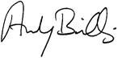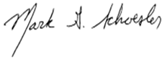

ANDY BILLIG MARK SCHOESLER
Senate Majority Leader Senate Minority Leader

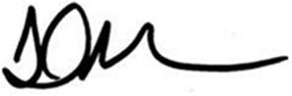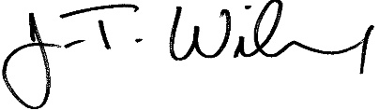
LAURIE JINKINS J.T. WILCOX
Speaker of the House House Minority Leader

