The Honorable Bob Ferguson August 27, 2021
Attorney General
PO Box 40100
Olympia, Washington 98504-0100

Attorney General Ferguson,

I’m writing to request a formal opinion from your office regarding proposed legislation that I hope to pass in the 2022 legislative session. Reducing greenhouse gas emissions resulting from burning fossil fuels in buildings will be one of the most difficult challenges in front of our state as we seek to meet the aggressive, science-based emissions reduction goals that Washington has set in RCW 70A.45.020. Enabling our public electric utilities to be full partners in this work is an important part of how we can meet this challenge. This strategy is discussed in the 2021 Washington State Energy Strategy (pp 77, action 2.4). However, the complicated body of law surrounding public utility fuel switching gives many of the stakeholders in the topic pause and has sparked uncertainty for some of my colleagues in the legislature. An official opinion from your office would be of significant value in response to that uncertainty as we work to advance the legislation and will give eligible public utilities additional confidence to utilize the tools enabled by the legislation if we are successful.

I believe that both Chris Kilduff and Glenn Blackmon have been in contact with members of your team regarding this topic. I understand that time is limited to prepare an opinion before the start of the session. If it isn’t possible to meet that deadline, I hope to have a follow up conversation about an alternative timeline and/or an informal opinion.

My request is as follows:

These questions concern sections 16 through 21 of House Bill 1084 (2021), which would grant express authority to municipal electric utilities and public utility districts to spend utility funds, in specified circumstances, to convert their customers’ equipment from fossil fuels to electricity. Assuming the enactment of these sections:
(1) If a municipal electric utility or public utility district adopts a beneficial electrification plan complying with section 16 or 17, respectively, would the expenditure of utility funds pursuant to that plan (e.g., investing in the electrification of customer equipment) be permissible under Washington law, including the state constitution?
(2) If a municipal electric utility or public utility district adopted a plan complying with section 19 or 21, respectively, to reduce its greenhouse gas emissions or achieve net-zero emissions, would the expenditure of utility funds for the purpose of achieving quantifiable and verified reductions in greenhouse gas emissions from homes and businesses receiving retail electric service from the utility be permissible under Washington law, including the state constitution?
(3) Does the proposed legislation allow a municipal electric utility or public utility district to expend utility funds in a manner that results in existing structures converting from one energy source to another, if consistent with a plan adopted under sections 16, 17, 19, or 21?

I appreciate any help you can offer, and I especially appreciate any status updates along the way as I plan my agenda for the 2022 session. Please let me know if there is other information I can provide to help you and your team with this work.

Warm regards,

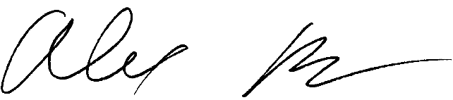

Alex Ramel
WA State Representative | 40th Legislative District

CC: Glenn Blackmon, Chris Kilduff, Jeffrey Even, Alicia Young, Jasmine Vasavada

