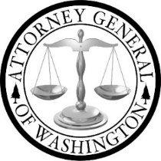

SAFE Advisory Working Group

AGENDA
May 20, 2020, 9:00 a.m. – 1:00 p.m.

Please join the meeting from your computer, tablet or smartphone.
https://global.gotomeeting.com/join/241811613

You can also dial in using your phone.
United States: +1 (646) 749-3122
Access Code: 241-811-613

1. | Call to Order & Establishment of Quorum  - Welcome & Introductions  - Review Legislative Authorization  - Adopt Agenda for May 20, 2020  - Questions & Discussion | 9:00 – 9:30 a.m.
2. | Updates  - 2019 Recommendations  - 2019 Legislative Session  - SAKI Grant  - Testing, Investigation, and Prosecution | 9:30 – 10:45 a.m.
3. | COVID-19 Impact on Survivors  - Questions & Discussion | 10:45 – 11:30 a.m.
4. | Break | 11:30 – 11:45 a.m.
5. | Victim Notification Best Practices Protocol  - Update  - Questions & Discussion | 11:45 – 12:45 p.m.
6. | Next Steps & 2020 SAFE Planning  - Questions & Discussion | 12:45 – 1:00 p.m.

