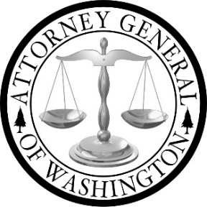

SAFE Advisory Working Group
AGENDA
November 5, 2019, 9:00 a.m. – 1:15 p.m.

Office of the Attorney General
800 Fifth Avenue, 20th Floor Chief Sealth Conference Room
Seattle, WA 98104

1. | Welcome and Voting Protocol  - Overview of Protocol  - Questions/Discussion | 9:00 – 9:15 a.m.
2. | Discussion and Voting on Recommendations for Storage of Unreported Kits  - Location for Storage  - Retention Time for Storage | 9:15 – 10:15 a.m.
3. | Discussion and Voting on Recommendations for Victim Advocacy Services  - Victim Advocates Role at the time of Sexual Assault Forensic Examination | 10:15 – 10:45 a.m.
4. | Discussion and Voting on Recommendations for Retention off Records and Evidence  - Retention Period for Records Associated with a Sexual Assault Case  - Retention Period for Evidence Collected During a Sexual Assault Forensic Examination | 10:45– 11:30 a.m.
5. | Discussion and Voting on Recommendations for Cold Case Resources  - Resources for Investigation and Prosecution of Cold Cases | 11:30 a.m. – 12:00 p.m.
6. | Discussion and Voting on Additional Recommendations  - Open Floor for Members to Present Additional Recommendations for Voting | 12:00 – 1:00 p.m.
7. | Update on Victim Notification Best Practices | 1:00 – 1:10 p.m.
8. | Next Steps and Wrap Up | 1:10 – 1:15 p.m.

