Washington State Legislature
Legislative Building

Olympia, WA 98504-0600

July 7, 2020

The Honorable Jay Inslee
Governor
State of Washington
Legislative Building
Olympia WA 98504

Dear Governor Inslee:

We are in receipt of your letter dated July 2, 2020 requesting extension of the statutory waivers and suspensions ordered in Proclamations 20-28.6 and 20-36.2.

Senator Billig and Speaker Jinkins support extension to September 1 as requested, but Senator Schoesler and Representative Wilcox support extension for a shorter time period. As RCW 43.06.220(4) requires the agreement of all four caucus leaders, we hereby extend the statutory waivers and suspensions cited in these proclamations until 11:59 p.m. August 1, 2020.

Sincerely,

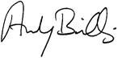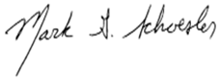

ANDY BILLIG MARK SCHOESLER
Senate Majority Leader Senate Minority Leader

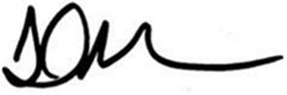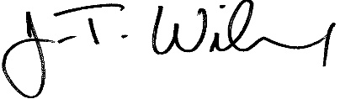
LAURIE JINKINS J.T. WILCOX
Speaker of the House House Minority Leader

